# Event Handling in Java

|  |
| --- |
| Changing the state of an object is known as an event. For example, click on button, dragging mouse etc. The java.awt.event package provides many event classes and Listener interfaces for event handling. |

## Java Event classes and Listener interfaces

|  |  |  |
| --- | --- | --- |
| **Event Source** | **Event Classes** | **Listener Interfaces** |
| JButton | ActionEvent | ActionListener |
|  | MouseEvent | MouseListener and MouseMotionListener |
|  | MouseWheelEvent | MouseWheelListener |
|  | KeyEvent | KeyListener |
|  | ItemEvent | ItemListener |
|  | TextEvent | TextListener |
|  | AdjustmentEvent | AdjustmentListener |
|  | WindowEvent | WindowListener |
|  | ComponentEvent | ComponentListener |
|  | ContainerEvent | ContainerListener |
|  | FocusEvent | FocusListener |

## Steps to perform Event Handling

Following steps are required to perform event handling:

1. Register the component with the Listener

## Registration Methods

For registering the component with the Listener, many classes provide the registration methods. For example:

* ****Button****
  + public void addActionListener(ActionListener a){}
* ****MenuItem****
  + public void addActionListener(ActionListener a){}
* ****TextField****
  + public void addActionListener(ActionListener a){}
  + public void addTextListener(TextListener a){}
* ****TextArea****
  + public void addTextListener(TextListener a){}
* ****Checkbox****
  + public void addItemListener(ItemListener a){}
* ****Choice****
  + public void addItemListener(ItemListener a){}
* ****List****
  + public void addActionListener(ActionListener a){}
  + public void addItemListener(ItemListener a){}

### Java Event Handling Code

We can put the event handling code into one of the following places:

1. Within class
2. Other class
3. Anonymous class

### Java event handling by implementing ActionListener

**import** java.awt.*;

**import** java.awt.event.*;

**class** AEvent **extends** Frame **implements** ActionListener{

TextField tf;

AEvent(){

*//create components*

tf=**new** TextField();

tf.setBounds(60,50,170,20);

Button b=**new** Button("click me");

b.setBounds(100,120,80,30);

*//register listener*

b.addActionListener(**this**);*//passing current instance*

*//add components and set size, layout and visibility*

add(b);add(tf);

setSize(300,300);

setLayout(**null**);

setVisible(**true**);

}

**public** **void** actionPerformed(ActionEvent e){

tf.setText("Welcome");

}

**public** **static** **void** main(String args[]){

**new** AEvent();

}

}

****public void setBounds(int xaxis, int yaxis, int width, int height);**** have been used in the above example that sets the position of the component it may be button, textfield etc.

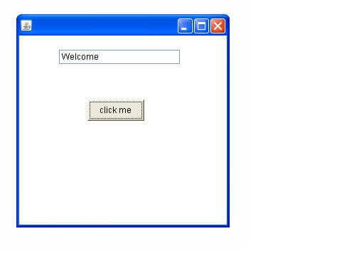

### 2) Java event handling by outer class

**import** java.awt.*;

**import** java.awt.event.*;

**class** AEvent2 **extends** Frame{

TextField tf;

AEvent2(){

*//create components*

tf=**new** TextField();

tf.setBounds(60,50,170,20);

Button b=**new** Button("click me");

b.setBounds(100,120,80,30);

*//register listener*

Outer o=**new** Outer(**this**);

b.addActionListener(o);*//passing outer class instance*

*//add components and set size, layout and visibility*

add(b);add(tf);

setSize(300,300);

setLayout(**null**);

setVisible(**true**);

}

**public** **static** **void** main(String args[]){

**new** AEvent2();

}

}

**import** java.awt.event.*;

**class** Outer **implements** ActionListener{

AEvent2 obj;

Outer(AEvent2 obj){

**this**.obj=obj;

}

**public** **void** actionPerformed(ActionEvent e){

obj.tf.setText("welcome");

}

}

### 3) Java event handling by anonymous class

**import** java.awt.*;

**import** java.awt.event.*;

**class** AEvent3 **extends** Frame{

TextField tf;

AEvent3(){

tf=**new** TextField();

tf.setBounds(60,50,170,20);

Button b=**new** Button("click me");

b.setBounds(50,120,80,30);

b.addActionListener(**new** ActionListener(){

**public** **void** actionPerformed(){

tf.setText("hello");

}

});

add(b);add(tf);

setSize(300,300);

setLayout(**null**);

setVisible(**true**);

}

**public** **static** **void** main(String args[]){

**new** AEvent3();

}

}